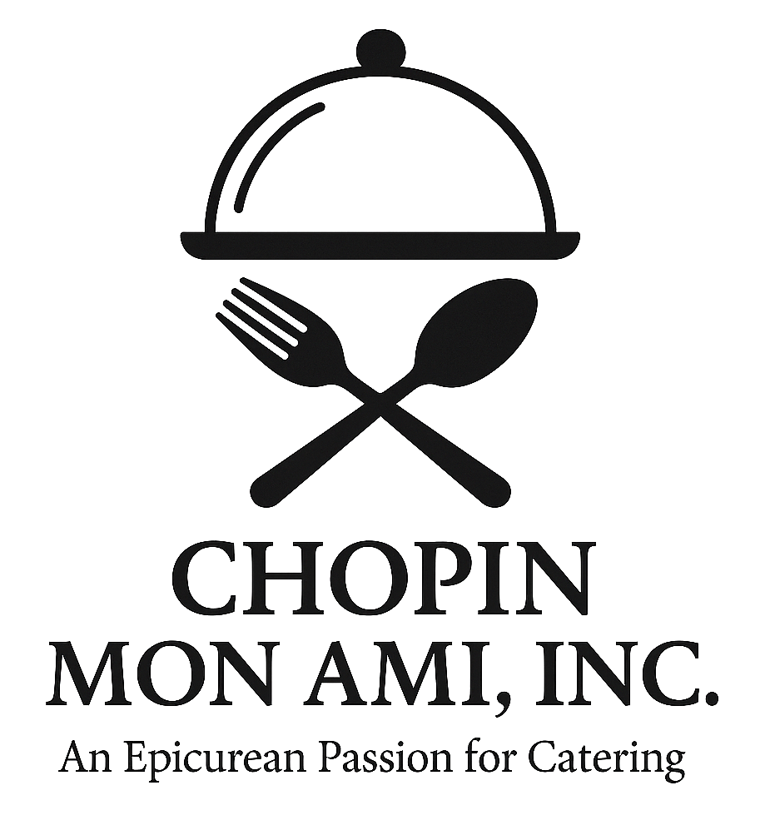

**Chopin Mon Ami Catering  
2025 – 2026 Menu**

An Epicurean Passion for Catering

# About Us

Since 2005, Chopin Mon Ami Catering has proudly served over 2,000 weddings and 450 corporate events. Voted “Best of Weddings” by The Knot 11 times, we are honored to be preferred vendors at Galveston’s finest venues: The Bryan Museum, The Trolley Station, The Garten Verein, Ashton Villa, The Tuscan Courtyard, and The Artisan.

# Hors d’Oeuvres

**Seasonal Fruit & Cheese Display:** Fresh fruits, cubed cheeses, and crackers. ($6 per person)

**Cold Seafood Station:** Chilled shrimp, oyster shooters, and crab claws over crushed ice. ($15 per person)

**Canapé Quartet:** Filo cups with pesto chicken, shrimp medley, spinach mousse, and brie. ($7 per person)

**Smoked Salmon Dill Canapé:** With dill mousse on cucumber rounds. ($7 per person)

**Island Shrimp:** Cajun-spiced Gulf shrimp with cocktail and tartar sauces. ($9 per person)

**Shrimp Kisses:** Jalapeño and jack stuffed shrimp wrapped in bacon. ($11 per person)

**Sausage Stuffed Mushrooms:** With cheese and parmesan topping. ($6 per person)

**Crab Stuffed Mushrooms:** Stuffed with fresh lump crab and herbs. ($9 per person)

**Antipasto Skewers:** Mozzarella, salami, artichoke, and olives. ($6 per person)

**Hawaiian Chicken Skewers:** Teriyaki-glazed chicken with peppers. ($5 per person)

**Hawaiian Beef Skewers:** Teriyaki-glazed tenderloin with peppers. ($7 per person)

**Cocktail Croissant Sandwiches:** Mini croissants with chicken salad, turkey, or roast beef. ($7 per person)

**Spring Rolls:** Pork and veggie with teriyaki and sweet & sour sauces. ($6 per person)

**Smoked Chicken Quesadillas:** Spicy chicken, Jack cheese, peppers, and cilantro. ($5 per person)

**Bacon Wrapped Chicken Bites:** In teriyaki sriracha glaze. ($6 per person)

**Blackened Shrimp Canapé:** With avocado mousse on cucumber rounds. ($7 per person)

**Chicken & Sausage Gumbo Shooters:** Topped with rice, served in shooter glasses. ($6 per person)

**Pulled Pork Sliders:** On chili lime spoons with raspberry chipotle. ($6 per person)

**Brisket Sliders:** Smoked brisket with BBQ sauce on jalapeño cheese buns. ($8 per person)

**Crispy Cauliflower Bites:** Buffalo or sesame glaze. Vegan & gluten-free. ($7 per person)

**Mini Crab Cakes:** With lemon-dill aioli. ($9 per person)

**Lamb Lollipops:** With rosemary balsamic glaze. ($11 per person)

# Hors d’Oeuvre Bars

**Queso Bar:** Blanco queso, taco meat, chicken, guacamole, jalapeños, onions, chips. ($9 per person)

**Mashed Potato Bar:** Served in martini glasses with toppings like cheese, bacon, and sour cream. ($7 per person)

**Mac & Cheese Bar:** BBQ brisket, jalapeños, bacon, onions, sour cream, salsa, breadcrumbs. ($8 per person)

**Mini Churro Station:** Served with sugar, cinnamon, chocolate, strawberry, and caramel sauces. ($6 per person)

**Ramen Bar:** Choice of meat or veggie broth, noodles, filet, shrimp, bok choy, nori, toppings. ($12 per person)

**Street Taco Bar:** Carne asada, pulled pork, mushrooms al pastor, tortillas, toppings. ($11 per person)

**Mediterranean Mezze Station:** Hummus, dolmas, olives, peppers, falafel, pita chips. ($10 per person)

**Upscale Slider Bar:** Beef, pork, black bean patties, artisan buns, gourmet toppings. ($10 per person)

**Mini Dessert Bar:** Brownies, lemon squares, cheesecakes, cookies. ($6 per person)

# Entrées

## Beef

**Petite Filet:** Grilled and seasoned with Marsala demi-glace.

**Whole Tenderloin:** Garlic-rubbed, slow-roasted, mushroom au jus.

**Stuffed Filet Mignon:** With mozzarella, basil, spinach, red pepper, mushroom au jus.

**Prime Rib Roast:** Slow-cooked and carved at buffet.

**Surf & Turf 1:** Stuffed tenderloin with grilled shrimp and lemon butter.

**Surf & Turf 2:** Petite filet with grilled shrimp and lemon butter.

## Chicken

**Tuscan Chicken:** Stuffed with mozzarella, mushrooms, spinach, sun-dried tomato, white wine sauce.

**Gumbo Stuffed Chicken:** Stuffed with sausage, peppers, onions, cheese, topped with gumbo sauce.

**Chicken Valentino:** Stuffed with red peppers and mozzarella, pink vodka sauce.

**Brazilian Chicken:** Grilled, topped with orange, tomato, onion, lime, parsley. Served with lemon rice.

**Apricot Bourbon Chicken:** Marinated and grilled with apricot bourbon glaze.

**Chicken Marsala:** Sautéed with mushrooms in Marsala wine.

**Chicken Piccata:** Sautéed with capers, lemon butter, and white wine.

**Chicken Parmesan:** Breaded, topped with marinara and mozzarella.

## Pork

**Roast Pork Loin:** Seasoned with garlic, salt, pepper, choice of sauce.

**Apple Stuffed Pork Loin:** Stuffed with sautéed apples, cinnamon, nutmeg, raspberry chipotle sauce.

**Dressing Stuffed Pork Loin:** Stuffed with cornbread dressing, pork gravy.

**Honey Glazed Pork Chops:** Marinated, grilled, glazed with honey soy sauce.

## Seafood

**Redfish Pontchartrain:** Topped with shrimp, mushrooms, peppers, Cajun cream sauce.

**Redfish with Mango Salsa:** Topped with mango, tomato, jalapeño, lime salsa.

**Lemon Dill Salmon:** Grilled, creamy dill sauce.

**Catfish with Shrimp Creole:** Grilled catfish with cilantro cream and grilled shrimp.

**Shrimp Orleans:** Creamy Cajun shrimp with peppers and onions over pasta or rice.

**Shrimp & Asparagus:** Sautéed shrimp and asparagus in lemon butter.

**Shrimp Etouffée:** Classic Cajun-style with rice.

# Menu Packages

**Texas BBQ Package:** Brisket, sausage, baked beans, potato salad, sliced bread, pickles, onions. ($28 per person)

**Pasta Bar Package:** Salad, grilled chicken, meatballs, marinara, Alfredo, pasta, breadsticks. ($25 per person)

**Fajita Bar Package:** Chicken, filet, rice, beans, tortillas, chips, tomatillo salsa, pico, toppings. ($27 per person)

**Gourmet Buffet Package:** Choice of chicken or pork, salad, 3 sides, honey butter rolls. ($26 per person)

**Prime Package:** Petite filet + chicken or pork, salad, 3 sides, honey butter rolls. ($34 per person)

**Seafood Package:** Seafood entrée, salad, 3 sides, honey butter rolls. ($36 per person)

**Surf & Turf Package:** Petite filet & grilled shrimp, salad, 3 sides, honey butter rolls. ($37 per person)

# Sides

Standard Sides:

* - Chopin Grilled Vegetables
* - Garlic Green Beans
* - Southern Style Green Beans
* - Honey Butter Carrots
* - Bourbon Glazed Carrots
* - Chopin Broccoli
* - Spinach Orzo
* - Rosemary New Potatoes
* - Garlic Mashed Potatoes
* - Wild Rice
* - Rice Pilaf

Premium Sides (+$2 per person):

* - Grilled Asparagus
* - Twice Baked Potatoes
* - Gourmet Mac & Cheese

# Salads

* - Mixed Greens Salad
* - Caesar Salad
* - Spinach Salad (+$2 per person)

# Bar Options

**Beer & Wine Package:** Includes 2 domestic and 2 import beers, Chardonnay, Cabernet, champagne toast, glassware, and barware. ($18 per person)

**Glassware Only:** Client supplies alcohol. Includes all bar glassware. ($2 per person)

# Dessert Enhancements

**Mini Dessert Bar:** Brownies, lemon squares, cheesecakes, cookies. ($6 per person)

**Italian Cannoli Bar:** Shells with sweet ricotta filling and toppings. ($6 per person)

**Upscale S’mores Station:** Gourmet chocolates, flavored marshmallows, and specialty grahams. ($6 per person)