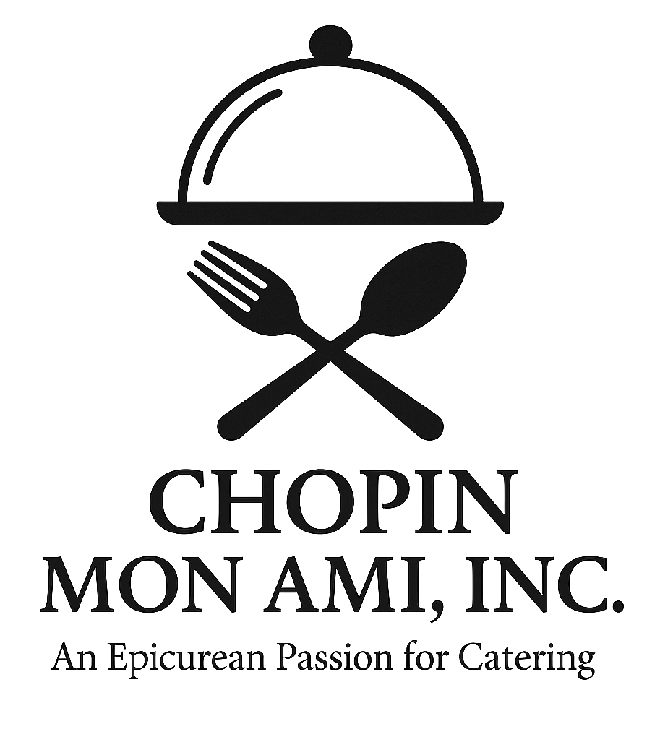
Chopin Mon Ami Catering
2026 – 2027 Menu
” An Epicurean Passion for Catering”

About Us
Since 2005, Chopin Mon Ami Catering has proudly served over 2,000 weddings and 450 corporate events. Voted “Best of Weddings” by The Knot 11 times, we are honored to be preferred vendors at Galveston’s finest venues: The Bryan Museum, The Trolley Station, The Garten Verein, Ashton Villa, The Tuscan Courtyard, and The Artisan. Chopin Mon Ami Catering is a FULL service catering company.

Hors d’Oeuvres
Seasonal Fruit & Cheese Display: Fresh fruits, cheeses, and crackers. ($6 per person)
Cold Seafood Station: Chilled shrimp, oyster shooters, and crab claws over crushed ice served with cocktail and tartar sauce and lemons. ($15 per person)
Canapé Quartet: Filo cups with basil pesto chicken, shrimp medley, spinach mousse, and brie mousse with a raspberry drizzle. ($7 per person)
Smoked Salmon Dill Canapé: With dill mousse on cucumber rounds. ($7 per person)
Island Shrimp: Cajun-spiced Gulf shrimp with cocktail and tartar sauces. ($9 per person)
Shrimp Kisses: Large shrimp wrapped in bacon. Choose a sauce (Bourbon, Teriyaki-Sriracha or Asia Chili Sauce) to toss them in or serve without sauce. ($11 per person)
Sausage Stuffed Mushrooms: Sausage crumble with cream cheese and spices piped into the mushroom and parmesan topping. ($6 per person)
Crab Stuffed Mushrooms: Stuffed with fresh crab, cream cheese and herbs. ($9 per person)
Antipasto Skewers: Mozzarella, salami, artichoke, pepperoni, cherry tomato and olives, drizzled with a balsamic reduction. ($6 per person)
Hawaiian Chicken Skewers: Teriyaki-glazed chicken with peppers and onions. ($5 per person)
Hawaiian Beef Skewers: Teriyaki-glazed petite filet with peppers and onions. ($7 per person)
Cocktail Croissant Sandwiches: Mini croissants with chicken salad, turkey, or roast beef, lettuce, tomato, mustard and mayo on the side. ($7 per person)
Spring Rolls: Veggie with sweet chili sauce. ($6 per person)
Smoked Chicken Quesadillas: Spicy chicken, Jack cheese, peppers, onions and cilantro rolled into a cone shape for presentation. ($5 per person)
Bacon Wrapped Chicken Bites: In teriyaki sriracha glaze. ($6 per person)
Blackened Shrimp Canapé: With avocado mousse on cucumber rounds. ($7 per person)
Chicken & Sausage Gumbo Shooters: Topped with rice, served in shooter glasses. ($6 per person)
Pulled Pork Sliders: Pulled Pork tossed in raspberry chipotle BBQ sauce on a brioche slider bun. ($6 per person)
Brisket Sliders: Smoked brisket with BBQ sauce on a brioche slider bun with pickles and onions. ($8 per person)
Crispy Cauliflower Bites: Buffalo or sesame glaze. Vegan & gluten-free. ($7 per person)
Mini Crab Cakes: With lemon-dill aioli. ($9 per person)
Lamb Lollipops: Grilled with rosemary and seasoning served with mint jelly. ($11 per person)

Hors d’oeuvre Bars (Everyone Loves Them)
Queso Bar: Blanco queso, beef taco meat, chicken taco meat, guacamole, jalapeños, onions, chips. ($9 per person)
Mashed Potato Bar: Served in martini glasses with toppings like cheese, bacon, green onions and sour cream. ($7 per person)
Mac & Cheese Bar: BBQ brisket, jalapeños, onions, sour cream, salsa, breadcrumbs. ($8 per person)
Mini Churro Station: Tossed with sugar, cinnamon, with chocolate, strawberry, and caramel sauces on the side. ($6 per person)
Ramen Bar: Choice of meat or veggie broth, noodles, petite filet, shrimp, Bok choy, nori, toppings. ($12 per person)
Mini Street Taco Bar: Carne asada, pulled pork, mushrooms al pastor, tortillas, toppings. ($11 per person)
Mediterranean Mezze Station: Hummus, dolmas, olives, peppers, falafel, pita chips. ($10 per person)
Mini Dessert Bar: Brownies, lemon squares, cheesecakes, cookies. ($6 per person)

Entrées

Beef
Petite Filet: Rubbed with a garlic puree, Grilled and seasoned with a course seasoning, served with Marsala demi-glace or red wine reduction demi-glace.
Whole Tenderloin: Rubbed with a garlic puree, Grilled and seasoned with a course seasoning, served with Marsala demi-glace or red wine reduction demi-glace.
Stuffed Filet Mignon: With mozzarella, basil, spinach, red pepper, served with a mushroom au jus.
Prime Rib Roast: Rubbed with garlic puree, seasoned with a course seasoning Slow-cooked and carved at buffet.
Surf & Turf 1: Whole tenderloin with grilled shrimp and lemon butter.
Surf & Turf 2: Petite filet with grilled shrimp and lemon butter.

Chicken
Tuscan Chicken: Stuffed with mozzarella, mushrooms, spinach, sun-dried tomato, served with white wine sauce.
Gumbo Stuffed Chicken: Stuffed with andouille sausage, peppers, onions, jack cheese, topped with gumbo sauce.
Chicken Valentino: Stuffed with red peppers and mozzarella, topped with pink vodka sauce.
Brazilian Chicken: Grilled, topped with orange, tomato, onion, lime, parsley in a light lemon lime sauce. Served with lemon rice.
Apricot Bourbon Chicken: Marinated and grilled with apricot bourbon glaze.
Chicken Marsala: Sautéed with mushrooms in Marsala wine sauce.
Chicken Piccata: Sautéed with capers, lemon butter, and white wine sauce.
Chicken Parmesan: Breaded and pan fried. Topped with marinara and mozzarella.

Pork
Roast Pork Loin: Seasoned with garlic, salt, pepper, choice of sauce or gravy.
Apple Stuffed Pork Loin: Stuffed with sautéed apples, cinnamon, nutmeg, topped with a raspberry chipotle sauce.
Dressing Stuffed Pork Loin: Stuffed with cornbread dressing, pork gravy on the side.
Honey Glazed Pork Chops: Marinated, grilled, glazed with honey soy sauce.

Seafood
Redfish Pontchartrain: Topped with shrimp, mushrooms, peppers, onions, celery and topped with a Cajun cream sauce.
Redfish with Mango Salsa: Topped with mango, tomato, jalapeño, lime salsa.
Lemon Dill Salmon: Grilled, creamy dill sauce.
Catfish with Shrimp Creole: Grilled or fried catfish topped with our creole sauce.
Shrimp Orleans: Creamy Cajun shrimp with colorful peppers and purple onions over pasta or rice.
Shrimp & Asparagus: Sautéed shrimp and asparagus in lemon butter sauce.
Shrimp Etouffée: Classic Cajun-style with rice.

Included in Menu Packages:
Choice of Pure White China or Gold Rim China, Flatware and Glassware for Dining, Sliver Roll Top Chaffing Dishes, Silver Serving Pieces, Glass Dressing Bowls, Silver and Brass Coffee Tureen, Salt and Pepper Shakers, Glass Sugar Caddies, Silver Hors d'oeuvres Serving Platters, Oval China Serving Platters, Large and Small Serving Trays and Tray Jacks, Cut The Cake, Plate and Pass Out, Serve The Couple, Package 2 meals and cake TO GO for the Couple , Iced Tea, Water and Coffee!
Texas BBQ Package: Sliced Brisket, sliced sausage, baked beans, potato salad, sliced bread, pickles, onions, spicy BBQ sauce and regular BBQ sauce. ($29 per person)
Pasta Bar Package: Salad, grilled sliced chicken, meatballs, marinara, Alfredo, choice of pasta, fresh garlic green beans, breadsticks. ($25 per person)
Fajita Bar Package: Chicken, petite filet, peppers and onions, Mexican rice, charro beans, flour tortillas, homemade chips, tomatillo salsa, red salsa Pico de Gallo, guacamole, sour cream, and mixed cheese. ($29 per person)
Gourmet Buffet Package: Choice of 2 entrees, chicken and pork, salad, 3 sides, honey butter rolls. ($27 per person)
Prime Package: Petite filet with a marsala demi-glace or red wine reduction demi-glace + chicken or pork dish, salad, 3 sides, honey butter rolls. ($35 per person)
Seafood Package: Seafood entrée, Chicken Dish, salad, 3 sides, honey butter rolls. ($37 per person)
Surf & Turf Package: Petite filet & grilled shrimp, salad, 3 sides, honey butter rolls. ($38 per person)

Not Included in Menu Packages: Linens, Napkins, Staff (Seated Dinner or Buffet Dinner), Hors d’oeuvres, Bar Glassware, Tax and Gratuity.

Sides
Standard Sides:
- - Fresh Chopin Grilled Vegetables
- - Fresh Garlic Green Beans
- -Fresh Southern Style Green Beans
- - Fresh Honey Butter Carrots
- -Fresh Bourbon Glazed Carrots
- - Fresh Chopin Broccoli
- - Spinach Orzo
- - Fresh Roasted Rosemary New Potatoes
- - Fresh Garlic Mashed Potatoes
- - Wild Rice
- - Rice Pilaf
Premium Sides (+$2 per person):
- - Grilled Asparagus
- - Twice Baked Potatoes
- - Gourmet Mac & Cheese

Salads
- - Mixed Greens Salad
- - Caesar Salad
- - Spinach Salad (+$2 per person)

Alcohol Bar Options
Beer & Wine Package: Includes 2 domestic and 2 import beers, Chardonnay, Cabernet, champagne toast, glassware, and barware. ($20 per person)
Glassware Only: Client supplies alcohol. Includes all bar glassware. ($2 per person)

Dessert Enhancements
Mini Dessert Bar: Mini Brownies, lemon square triangles, mini cheesecakes, assorted cookies. ($6 per person)
Italian Cannoli Bar: Shells with sweet ricotta filling and toppings. ($7 per person)
Upscale S’mores Station: Chocolates, marshmallows, and specialty grahams with wood burning mini fire pits and marshmallow grilled skewers. ($8 per person)

